COORDINATION OF BANK PENSIONERS’ AND RETIREES ORGANISATIONS
Flat No. 1103, Block-3B, S.M.R. Vinay Fountainhead, Culvary Temple Road,
Hydernagar, Hyderabad – 500 049.
__________________________________________________________________________________
A.Ramesh Babu K.V.Acharya
Joint Convener Joint Convener,
Flat No 1103, Block 3B, J-208 Vijay Rattan Vihar,
S.M.R. Vinay Fountainhead, Sector 15, Part II,
Culvary Temple Road, Gurugram -122001
Hyderabad 500 049 Mobile: 09868220338
Mobile: 09849381995 E-mail: acharyavedavyasa46@gmail.com
E-mail: babu2609@gmail.com
__________________________________________________________________________________

Circular No. 010/2017 Dated: 02.08.2017

Dear Comrades,

ENSUING WAGE REVISION AND PENSIONERS AND RETIREES ISSUES

The 11th Bipartite settlement negotiations have commenced and already few meetings have taken place between the UFBU and IBA. The issue raised by IBA in regard to coverage of the settlement has come as a hurdle to cross before the commencement of a meaningful dialogue.
Irked by the issue of partial mandate by some of the member Banks and also the unnecessary controversies in regard to the scope and coverage of the ensuing settlement, the UFBU also has given a set of action programmes asking its membership to be ready for the struggle.

The UFBU has included the Pensioners and Retirees issues in their Charter of Demands. They have also insisted that items listed in the Record Note at the time of signing in the last settlement concerning the Pensioners and Retirees should be taken up on priority basis and IBA has agreed to have a separate discussion with the UFBU on the Record Note. We have requested the UFBU to take into consideration Charter of Demands submitted to them by the Retirees’ Organisations along with their Charter of Demands. We have appealed to all the Constituents of UFBU to take up the Bank Pensioners and Retirees issues to the logical conclusion and meet out justice to the ageing Retirees, be it in respect of 100% DA neutralisation, Improvement in Family Pension, Pension Updation, Improved Medical Insurance (including bearing the cost of the premium by the Banks as in the case of serving employees), 2nd option of pension to very few left out compulsorily retired officers and a small number of resignees who have put in pensionable service under VRS scheme.

We have also met with a team of office bearers Com. Franco, General Secretary AIBOC, Com. C.H. Venkatachalam, General Secretary AIBEA and personally talked to Com. Sanjeev K Bandlish, UFBU Convenor and explained in detail about our issues and also impressed upon them that the cost implications in respect of our issues would be a meagre sum approximately not exceeding on an average Rs. 100 crores per Bank per year for resolution of all the above issues as per the terms of settlement right from the Pension settlement 1993 and Pension Regulation 1995. And the entire cost would be taken care by the robust Pension Fund of nearly two lakhs crores. Hence the resolution of the issues would in no way affect the profitability of the Banks.
COORDINATION OF BANK PENSIONERS’ AND RETIREES ORGANISATIONS
Flat No. 1103, Block-3B, S.M.R. Vinay Fountainhead, Culvary Temple Road,
Hydernagar, Hyderabad – 500 049.

Moreover, the Banks are also under an obligation to provide for Pension Fund annually as per the Actuary’s investigation of the Pension Funds specified in the Pension Regulations because Bank Employees Pension Scheme is a DEFINED BENEFIT PENSION SCHEME and thereby a deferred wage.

Meanwhile we are also pursuing the matter with Ministry Officials in the Department of Financial Services and also met concerned Ministers pointing out the inordinate delay being caused in resolving the most humanitarian issues of 100% DA neutralisation and improvement in Family Pension. The delay has been causing dismay, pain and humiliation to the veterans of Banking Industry. Forcing the Pensioners to seek relief from Courts which involves lot of financial burden and time make us wonder as to why Bank-men are singled out for such harsh treatment in spite of their yeomen service to the nation through the implementation of social welfare schemes of the Government since the nationalisation of the Banks.

The one positive development for us in our struggle for more than a decade is the resolution of anomalies that had arisen after Bipartite Settlements affecting the SBI Retirees and we are happy that about 40,000 aged SBI Retirees got the arrears due to them in July 2017.

We fondly hope that this will be a prelude to further successes in respect of other issues for which we have been struggling.

Meanwhile we have taken up with IBA the Super Top-up Policy offered by United India Insurance Co. to make it administratively easily implementable through the respective Banks as the base policy is from United India Insurance Company only. We have also taken up with UFBU and its constituents to take up the matter with IBA and ensure settlement of the issue before the due date for renewal of the present policy.

With regards,

Yours comradely,
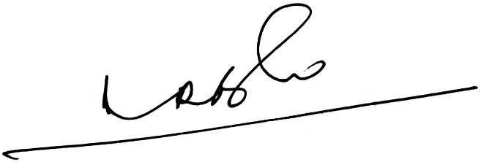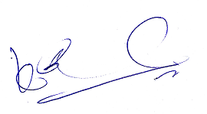
- RAMESH BABU) (K.V. ACHARYA)
JOINT CONVENERS

